**GUIDELINES FOR IMPLEMENTING MASK-RCNN**

Clone the repository:

!git clone <https://github.com/AkashAVI/MaskRCNN.git>

Install Requirements:

!pip3 install -r /content/MaskRCNN/requirements.txt

Import dataset from GitHub

!git clone [https://github.com/AkashAVI/caravana.git](https://github.com/AkashAVI/caravana.git )

Original Dataset (5K images) : <https://www.kaggle.com/c/carvana-image-masking-challenge/data>

**Training:**

**Local Environment:**

!python /content/MaskRCNN/train.py

Input images & Target masks should be in the ‘**data/images**’ & ‘**data/masks**’ folders respectively. The number of classes of segmentation, number of epochs and the training hyperparameters can be adjusted in the train.py script.

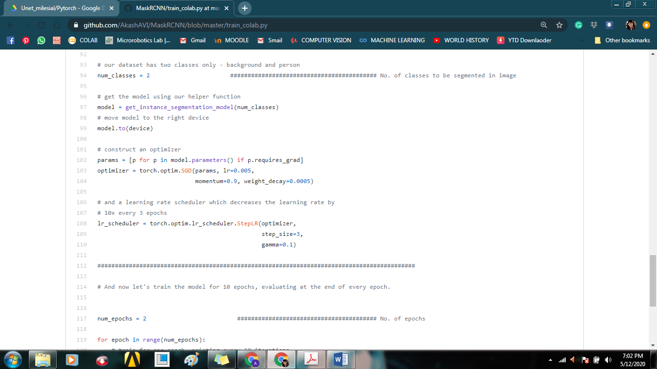

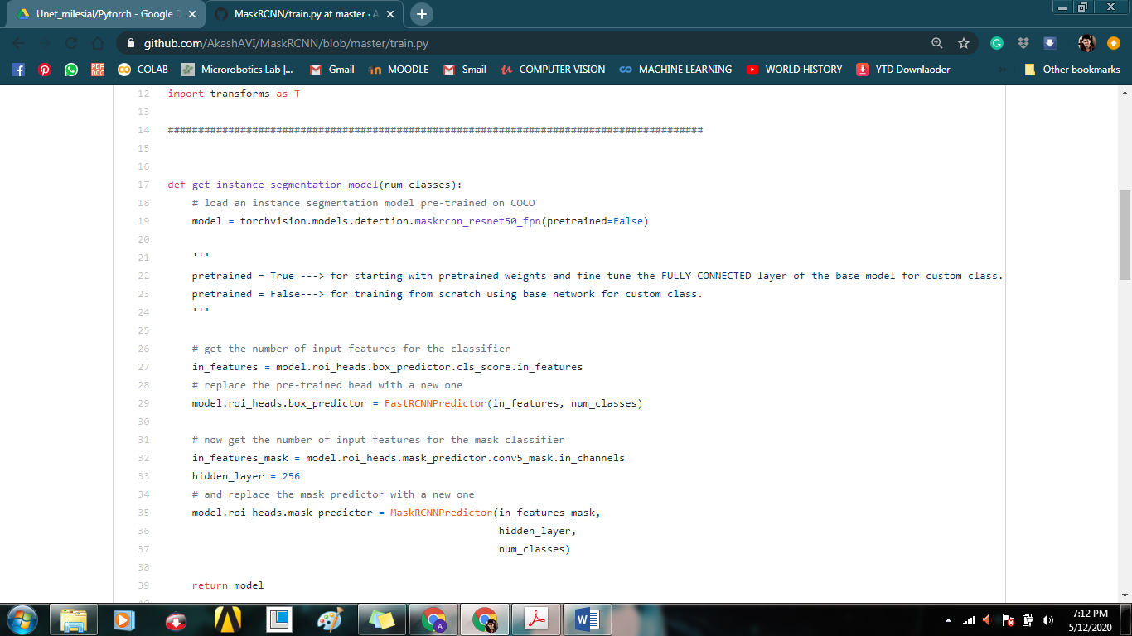**For Fine Tuning the network from Pre-trained weights change the ‘False’ to ‘True’**

**Colaboratory Environment:**

!python /content/MaskRCNN/train_colab.py

Copy the path of the folder containing the Input ‘images’ folder and Target ‘masks’ folder and paste them within the <> indicated.

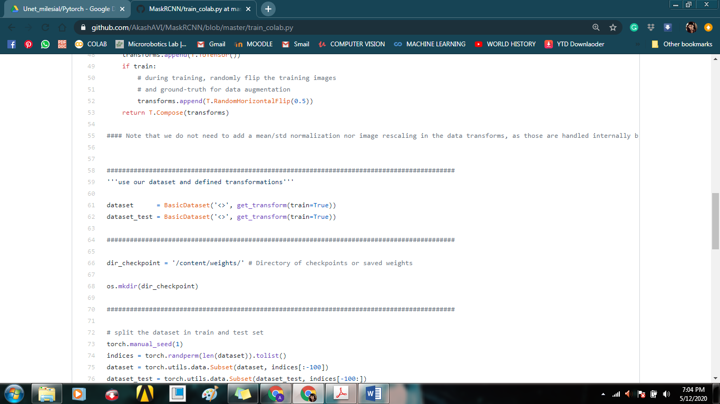

**Inference:**

The optimised weights corresponding to each epoch are stored in the **CP_epoch<epoch#>.pth** file inside the **dir_checkpoint**.

The last checkpoint **CP_epoch<last>.pth** is the model file with the fully optimized weights.

Copy the path of this file to the <model path> in **predict.py**.

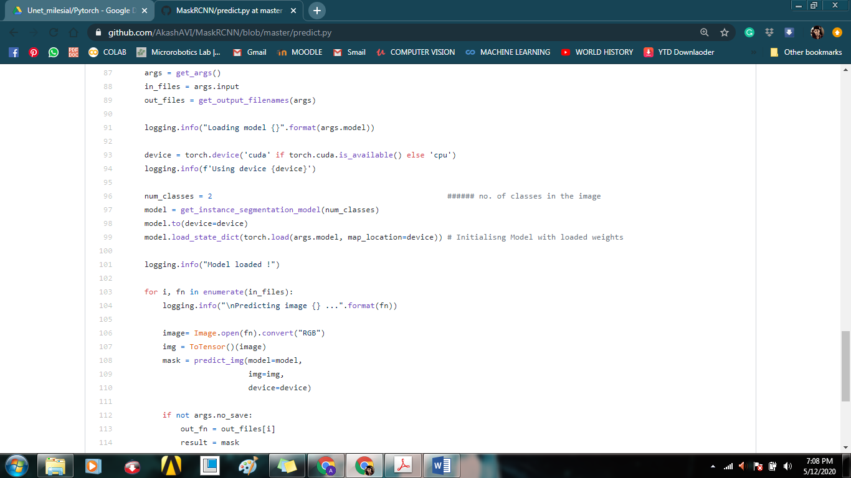The number of classes of objects in the image to be masked can be changed in the predict.py script:

Run the **predict.py** with the given input arguments:

!python predict.py -m <model path> -i <test image path> -o <output path>

